Spectral Arts: Founded in Winter of 2007- (Performance Art). Spectral Arts combines live acoustic music (guitar and percussion) with poetry that is both spoken and sung. The music and poetry have been described as transcendental and embodying a beautiful, as well as an ethereal, visionary quality.
Ghost House Studio is a working music and art studio in the Mountains of the New River Valley that has been involved in a variety of bands through the years (since 1985) performing in the genres of Alternative Rock, Bluegrass and Performance Art. The Studio currently produces music from the artists of Spectral Arts and The Ghost House Collective
Band Members: Doug "Eagle" Veit (Percussion/Production/Engineering), Ken Ostrander (Guitar/Editing) "Soupbone" Phill Stevens (Bass/ Guitar/ Mandolin), T. Byron Kelly (Poetry/Vocals/Bass/Trumpet/Bells/Guitar), Cory Tambourine (Percussion, Guitar, Bass), Amy Kelly Austin (Videography/Editing/Communications).
Blue Ridge Mountains, VA
*Visit our new sites @
http://www.ghosthousestudio.com
http://www.spectralva.com
https://twitter.com/ghosthouseva
http://soundcloud.com/ghosthousestudio
** "What are the characteristics of Performance Art? • Performance Art is live. • Performance Art has no rules or guidelines. It is art because the artist says it is art. It is experimental. • Performance Art is not for sale. It may, however, sell admission tickets and film rights. • Performance Art may be comprised of painting or sculpture (or both), dialogue, poetry, music, dance, opera, film footage, turned on television sets, laser lights, live animals and fire. Or all of the above. There are as many variables as there are artists. • Performance Art is a legitimate artistic movement. It has longevity (some performance artists, in fact, have rather large bodies of work) and is a degreed course of study in many post-secondary institutions. • Dada, Futurism, the Bauhaus and the Black Mountain College all inspired and helped pave the way for Performance Art. • Performance Art is closely related to Conceptual Art. Both Fluxus and Body Art are types of Performance Art. • Performance Art may be entertaining, amusing, shocking or horrifying. No matter which adjective applies, it is meant to be memorable." *From Art History 101 http://arthistory.about.com/cs/arthistory10one/a/performance.htm

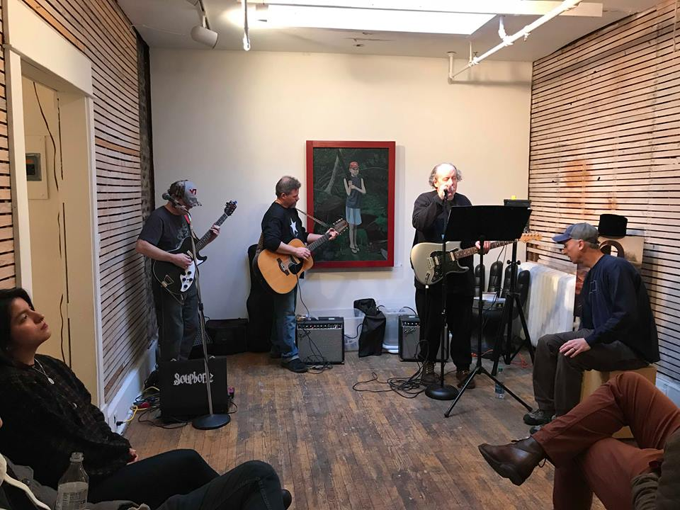
Spectral @ XYZ Art Gallery Photo by Callie Gramling-Gobes

